Creating table for employee salary:

create table emp_salary(

emp_id int primary key,

emp_name varchar(20),

salary int

);

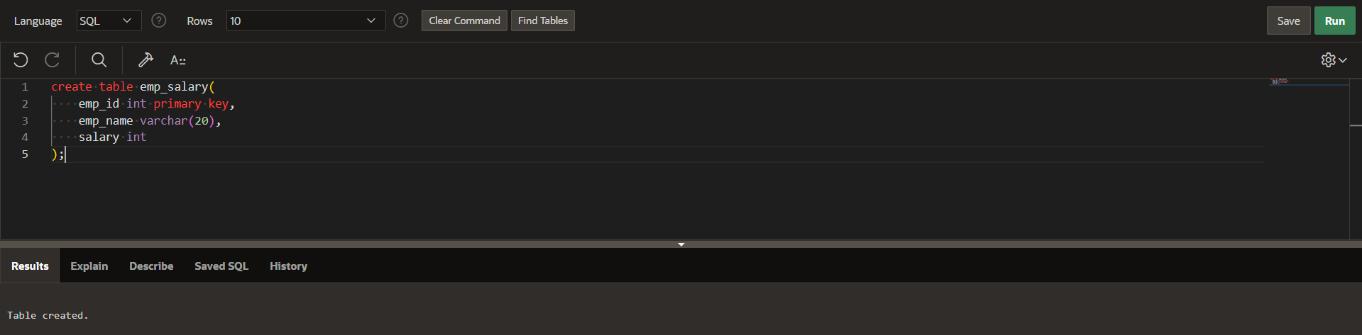

Inserting values in table:

insert into emp_salary

values(1,'rupesh',10000);

insert into emp_salary

values(2,'harshit',20000);

insert into emp_salary

values(3,'uday',30000); 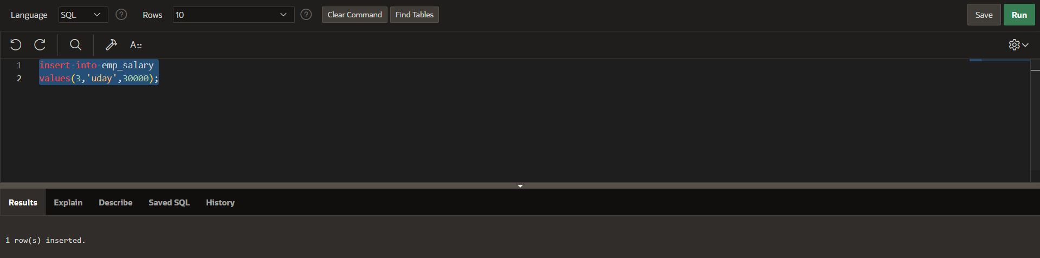

creating procedure for updating procedure:

create or replace procedure salary_raise

(

e_id in emp_salary.emp_id%type,

e_raise in number

)

is

begin

update emp_salary

set salary=salary*(1+e_raise/100)

where emp_id=e_id;

end salary_raise; 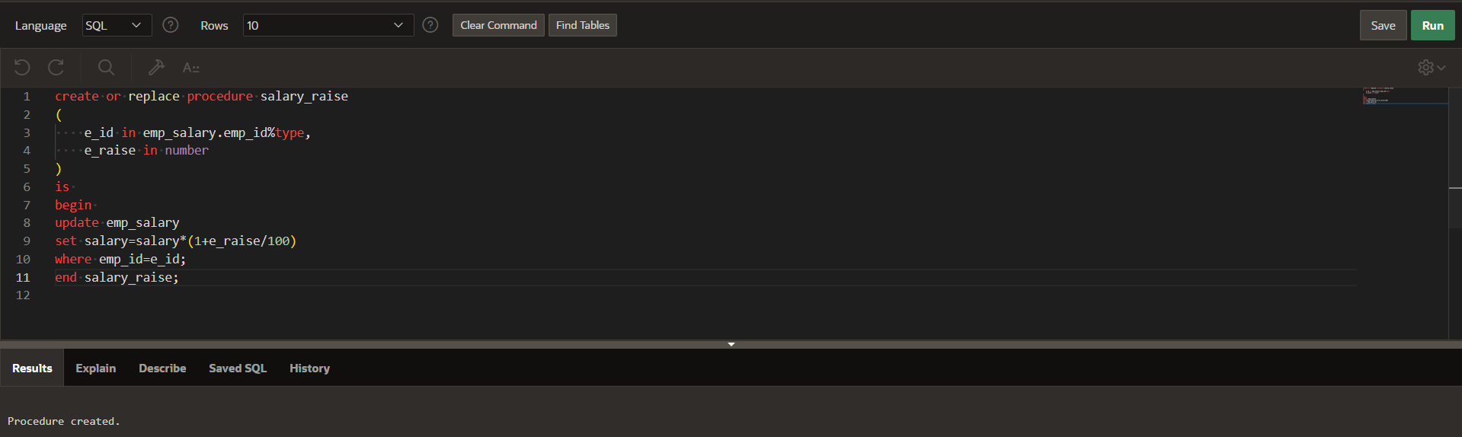

using procedure in plsql:

begin

salary_raise(1,10);

end;

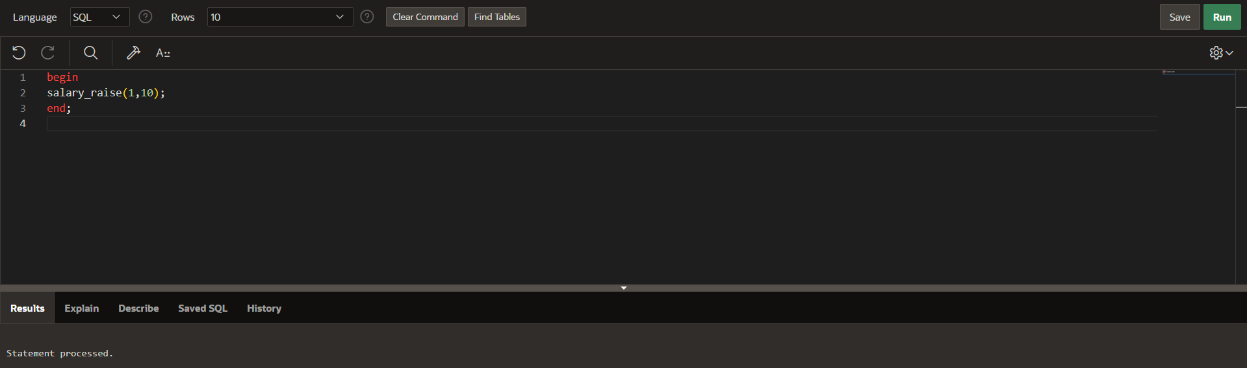

Displaying table:

Select *from emp_salary;  
